**Problem**: AI-Generated Medical Research Papers

**Graphical Solution**:

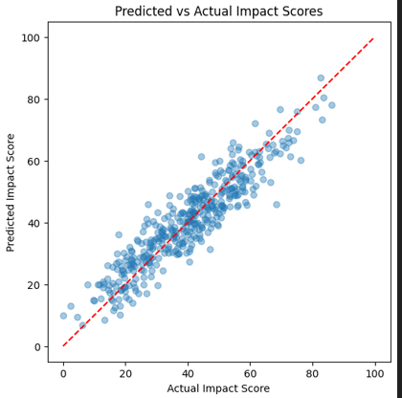

**Execution Output:**

# Step 1: Install dependencies

!pip install pandas numpy scikit-learn xgboost shap matplotlib streamlit --quiet

# Step 2: Imports

import numpy as np

import pandas as pd

import matplotlib.pyplot as plt

from sklearn.model_selection import train_test_split

from sklearn.preprocessing import StandardScaler

from sklearn.metrics import mean_absolute_error, r2_score

import xgboost as xgb

import shap

import joblib

# ============================================================

# Step 3: Generate synthetic environmental data

# ============================================================

def generate_synthetic_env_data(n=2000, seed=42):

    np.random.seed(seed)

    emissions = np.random.gamma(2, 10, n)

    water_use = np.random.normal(500, 200, n).clip(min=10)

    land_disturb = np.random.exponential(1.5, n)

    proximity = np.random.exponential(10, n)

    pop_density = np.random.normal(300, 250, n).clip(min=1)

    project_scale = np.random.choice(["small","medium","large"], size=n, p=[0.5,0.35,0.15])

    ndvi = np.random.uniform(0,1,n)

    is_protected = (proximity < 2).astype(int)

    # synthetic impact score (target)

    impact_score = (

        0.4 * (emissions / (emissions.max()+1)) +

        0.2 * (water_use / (water_use.max()+1)) +

        0.25 * (land_disturb / (land_disturb.max()+1)) +

        0.3 * (1 - ndvi) +

        0.15 * (is_protected) +

        0.2 * (np.where(project_scale=="large", 1,

                        np.where(project_scale=="medium", 0.5, 0)))

    )

    impact_score = (impact_score + np.random.normal(0,0.05,n))

    impact_score = (impact_score - impact_score.min()) / (impact_score.max()-impact_score.min())

    impact_score = (impact_score * 100).round(2)

    df = pd.DataFrame({

        "emissions_ton_per_year": emissions,

        "water_use_m3_per_day": water_use,

        "land_disturb_ha": land_disturb,

        "proximity_km": proximity,

        "population_density": pop_density,

        "project_scale": project_scale,

        "ndvi": ndvi,

        "is_protected": is_protected,

        "impact_score": impact_score

    })

    return df

df = generate_synthetic_env_data()

df.head()

# ============================================================

# Step 4: Preprocess & Split

# ============================================================

df = pd.get_dummies(df, columns=["project_scale"], drop_first=True)

X = df.drop("impact_score", axis=1)

y = df["impact_score"]

X_train, X_test, y_train, y_test = train_test_split(X, y, test_size=0.2, random_state=42)

scaler = StandardScaler()

num_cols = X_train.select_dtypes(include=[np.number]).columns

X_train[num_cols] = scaler.fit_transform(X_train[num_cols])

X_test[num_cols] = scaler.transform(X_test[num_cols])

# ============================================================

# Step 5: Train XGBoost model

# ============================================================

dtrain = xgb.DMatrix(X_train, label=y_train)

dtest = xgb.DMatrix(X_test, label=y_test)

params = {

    "objective": "reg:squarederror",

    "max_depth": 6,

    "eta": 0.1,

    "subsample": 0.8,

    "seed": 42

}

bst = xgb.train(params, dtrain, num_boost_round=150)

preds = bst.predict(dtest)

mae = mean_absolute_error(y_test, preds)

r2 = r2_score(y_test, preds)

print(f"✅ Model trained — MAE: {mae:.3f} | R²: {r2:.3f}")

# ============================================================

# Step 6: Visualize predicted vs actual

# ============================================================

plt.figure(figsize=(6,6))

plt.scatter(y_test, preds, alpha=0.4)

plt.xlabel("Actual Impact Score")

plt.ylabel("Predicted Impact Score")

plt.title("Predicted vs Actual Impact Scores")

plt.plot([0,100],[0,100],"r--")

plt.show()

# ============================================================

# Step 7: Explainability with SHAP

# ============================================================

explainer = shap.TreeExplainer(bst)

sample_X = X_test.sample(200, random_state=42)

shap_values = explainer.shap_values(sample_X)

plt.title("Feature importance summary (SHAP values)")

shap.summary_plot(shap_values, sample_X, show=True)